COURSE OUTCOME:
➢ Course Description:

Economics Course Description: This is a rapidly moving 9 weeks course designed to give the student a basic understanding in the subject of Economics. Students will examine the allocations of scarce resources and the economic reasoning used by government agencies and by people as consumers, producers, savers, investors, workers and voters. Key elements of the course include the study of scarcity, supply and demand, market structures, the role of government, national income determination, money and the role of financial institutions, economic stabilization, and trade. Students will examine the key economic philosophies and economists who have influenced the economies around the world in the past and present. Informational text and primary sources will play an instrumental part of the study of economics where it is appropriate.

➢ Curriculum
Economics Standards: http://tn.gov/assets/entities/education/attachments/std_ss_economics.pdf

Carter High School-School Fusion Site: http://carterhs.knoxschools.org/

INSTRUCTION:

➢ General Pacing

Concepts and Objectives:
Module 1.0: Scarcity and Economic Reasoning
- Students will understand that productive resources are limited; therefore, people cannot have all the goods and services they want. As a result, they must choose some things an give up others.

Module 2.0: Supply and Demand
- Students will understand the role that supply and demand, prices, and profits play in determining production and distribution in a market economy.

Module 3.0: Market Structures
- Students will understand the organization and role of business firms and analyze the various types of market structures in the United States economy.

Module 4.0: The Role of Government
- The student will understand the roles of government in a market economy are provisions of public goods and services, redistribution of income, protection of property rights, and resolution of market failures.

Module 5.0: National Economic Performance
- Students will understand the means by which economic performance is measured.

Module 6.0: Money and the Role of Financial Institutions
- Students will understand the role of money and financial institutions in a market economy.

Module 7.0: Trade
- Students will understand why individuals, businesses, and governments trade goods and services and how trade affects the economies of the world.

➢ Materials Needed –
Paper, Pencil, Textbook, Highlighters, Calculator (Unit 2 and Unit 3), Notebook (three-ringed binder)/folders
-Notebook Requirements… 1) Three-ringed binder 2) 7 Dividers 3) Notebook Paper
➢ Teacher Wants (optional) –
Pens Hand sanitizer
Notebook Paper Kleenex
construction paper or colored copy paper tape – masking, duct, clear packing, or Scotch
magic markers Post-it notes (medium sized - different colors)

➢ Fees -- there are no additional fees associated with this course
➢ Resources

Textbooks: Economics (Prentice Hall)
Possible Videos:
Clips from:
'Capitalism: a Love Story' ; 'Wall Street: Money Never Sleeps'; 'Inside Job' ; 'The Corporation' 'The Big One' ; Shark Tank ; Youtube videos ; additional videos from various online sources
Access to the Internet: Students will need to have access to the Internet. Those who do not have the Internet at home should use the resources available at CHS to access the Internet.

- Statement concerning the option of alternatives for material deemed objectionable by parent/student.
If you do not approve of a specific resource listed in this syllabus, please make your request to me in writing and an alternative assignment and/or materials will be provided. The request should include your name, the child's name, the specific activity/materials in which you do not want your child to participate or to which you do not want them exposed, and the nature of your objection.

ASSESSMENT:
➢ Expectations

- Student learning will be accessed through a series of daily assignments, in-class and take-home writings, formal essays, group projects, document analyses, current events, debates, participation, review assignments, and unit tests. Students are expected to complete assignments by the time they are due. Students will not be allowed to turn in daily activities late that are expected to be completed during class without approval. A deduction of 10% per day will be assigned to any assignment that is turned in late unless special circumstances prevail and we are contacted by a parent immediately before or after an assignment is due.
- Completion of daily and homework assignments, as well as participation, is essential to being successful in class. Students who do not complete these types of assignments will find passing this course impossible.
- If you are absent, you are to complete our absent work within the allowed time frame as described in the student handbook.
- Cheating of any kind will not be tolerated. This includes allowing someone to copy your assignments! Cheating will result in a zero for that assignment or test.

➢ Grading Policy

All daily work comprises 75% of their overall grade. Points are cumulative.
1. Class Participation: 20 points / week (roughly 4/day)
2. Daily Assignments/Quizzes : various
3. Weekly Notebook Checks: 20 points / week
4. Unit Exam Review Sheet (5): 30 points
5. Unit Exams (5): 100 points

The quantitative Final Exam is 25% of the overall grade. This test is mandatory for all students.
Extra Credit is rare, and should not be expected. Any student who has a missing assignment will not be allowed to do extra credit until that assignment is completed, even if the completion of that assignment does not receive any points as a result of being past ten days late. Students must demonstrate a true commitment to assignment completion and understanding before being given extra opportunities.

Assessment Response 'Post-Its': will be used for pre and post assessing daily lessons, as well as reflection writing. These will count in the weekly Participation grade.
Test Reviews: will be required and graded for completion.
*Formal Writing Assignments: Students will be expected to complete a series of formal writing assignments of various lengths during this course. These assignments are to be spell-checked / grammar-checked. Students are also expected to do their own work - plagiarized responses will receive an automatic zero and may result in disciplinary actions. Please see the 'Honor Code' below for further details. Please contact us with any questions about plagiarism that you may have in advance of an assignment.
Final Exam: Students are required to take the Final Exam covering the Essential Objectives covered in this course. The Final exam makes up 25% of a student’s final grade. All students are required to take the exam on the day scheduled. No early exams will be given, regardless of vacation schedules.

*I reserve the right to make reasonable changes to the structure of various assessments if unforeseen developments effect our schedule (testing dates need to be changed, incentive points, etc.)

Grading Scale:
93-100 A
85-92 B
75-84 C
70-74 D
0-69 F

Make-Up Work Policy/Late Work Policy
1. All assignments must be requested within 3 days of returning to school.
2. It is the student’s responsibility to pick up their make-up work before or after class.
3. We will be watching quite a few video clips in this class - if you are absent on a film day YOU WILL BE GIVEN AN ALTERNATIVE ASSIGNMENT that requires you to complete a current event task for the topic of discussion on that given day. GUIDELINES FOR COMPLETION WILL BE FIRMLY ESTABLISHED BY THE TEACHER.
4. Special consideration for due dates will be given for extended absences due to illness or other extenuating circumstances.
5. Unless due to extended absences, no make-up work will be accepted from previous units.
6. Test and Quiz make-ups will be done before or after school unless other arrangements with the teacher are made.
7. 10% will be deducted from each assignment for every day it is late.

➢ Portal Post Policy – I will Post Grades to the Portal at least once per week.

In order to give timely feedback, I will update grades at least once per week.

GENERAL EXPECTATIONS:

Students:
Tardy Policy: Please consult the Student Handbook for complete policy. Be aware that 3 tardies is an absence. I will strictly follow KHS policy for tardies.
Absence Policy: Please refer to the Student Handbook for the Absence Policies. Students who have no more than 2 absences by the end of the course will have their lowest test grade dropped.
Along with the county and school rules, I expect my students to:
1. Be respectful of the teacher, classroom property, and other classmates; no discriminatory language or profanity will be tolerated, nor will any student be allowed to interfere with another student’s right to learn.
2. Follow directions the first time asked; this includes sitting in assigned seats.
3. Complete all assignments by their due dates;
4. Cell phones will be not be used for non-instructional purposes. I will adhere strictly to the cell phone policy outlined in the Student Handbook. Parents, please do not communicate with your child during class time via the cell phone. Emergency information should be communicated through the front office at 865-932-8146.

➢ Classroom Policy/Procedures
1. Bring binder, notebook/paper, and ink pen to class every day.
2. use only standard blue or black ink pen only. No magic markers, glitter pens, pencils, or colored ink. Assignments written in anything other than blue or black ink will have to be redone in ink, with grade reductions for turning in late assignments applying. By Midterm, no student should be making this mistake; after Midterm, assignments written in anything but pen will not be graded.
3.Put names on papers. Papers without a name will be trashed without any grade assigned to them.
4. Stay awake! Detention will be assigned to students who choose to sleep after being given one warning.
5. No food, drink, gum, or candy will be allowed in this classroom without permission (beverage in sealable container is ok). Exceptions will be made to accommodate medically documented, school approved medical conditions. Food and drink items being consumed in this classroom without permission will be thrown away and discipline will be applied.

In addition....

o Follow the teacher’s first request
o Do not talk while the teacher is talking
o No inappropriate comments, language and gestures.
o Treat each other and the teacher with respect.
o No sleeping in class.
o Behave like an adult to be treated like an adult

Failure to follow the rules will result in the following:
1. 1st offense: warning
2. 2nd offense: isolation in the classroom and staying after class
3. 3rd offense: detention and parent notification*
4. 4th offense: office referral
*Some offenses will result in automatic detention and/ or office referral. Please see Detention Schedule for further information

➢ Honor Code
Students must do their own work. Students are not expected to give or receive answers to or from other students or copy from other sources as if it were their own work (plagiarism). Cheating and/or plagiarism will not be tolerated!

Teacher:
➢ Communication:
I believe an effective classroom addresses both the students’ and teacher’s needs. Therefore, I expect there to be mutual respect, cooperation, and effort during all class meetings. I will do my best to accommodate your child’s needs, and as a result, I expect that your child will do his or her best. Although I understand situations arise and
students often undervalue the importance of classroom and homework assignments, organization, and tests, I will not continually allow students to make up work because of their delinquency in completing assignments. Every student is given the opportunity to succeed – an “A” is not a guarantee. Therefore, if you see a concern with your child’s grades, please notify me. It is easier for me to understand your expectations if we communicate – I do not know what your expectations are, your child’s capabilities and limitations, or if problems are occurring if we do not communicate. The earlier we can correct problems, the more likely bad habits are turned into productive behaviors and complicated tasks become easier.

Contact Information:
The best way to communicate with me is via email. I can be reached at: dan.peters@knoxschools.org. You can access my email through the CHS website Faculty page. Please give me at least 24 hours to respond to any communication - I spend the majority of my day in class teaching, not on my computer. Feel free to ask any questions or address any concerns. Together we can make this a successful semester!

➢ Aspen:
The class webpage will be updated regularly with important class information and assignments.

➢ Intervention:
I will be happy to assist your child before or after school with any problem they are having. Please make prior arrangements, however.
Hive Time is instructional/remedial/enrichment time. Students will not be allowed to do test make ups during this period, but it may be a time for students to receive individual assistance.

Board Policy I-‐431
Issued: 7/95
Revised: 6/08

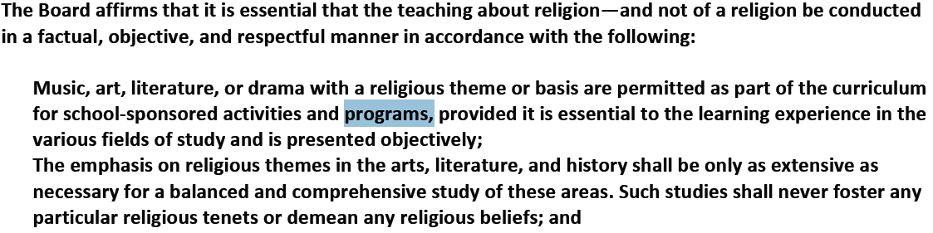

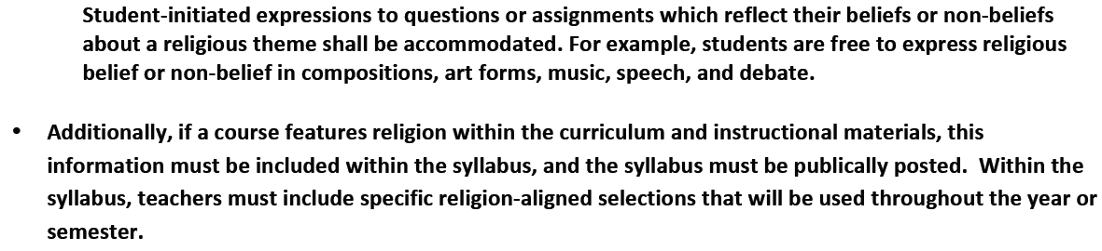

Dear Parent,
I would like to take this opportunity to welcome your child to my Economics class. In this class, I as well as the administration at Carter High School, have extremely high expectations of student success. It is my philosophy that success comes from teachers, students, and parents working together.
I would like to encourage you to take some time to read the course materials that your child has been given. In it you should find: a class syllabus, a copy of the rules and expectations, and a course description. Please review the standards and requirements with your child. These sheets should be kept in each student’s folder for reference. At the bottom of this sheet, you will notice a confirmation form for this letter. If you would please, read, sign, and have your child return this slip to me. Please have a phone number and/or email address to insure better communication. This slip is actually your child’s first assignment. Each student, who returns this sheet by 8/19/16, will receive full credit for the assignment (20 points).
In any event that you may need to contact me, I can be reached at Carter High School at dan.peters@knoxschools.org. Thank you for your cooperation and support in advance. I look forward to a successful year and working with your child throughout their high school experience. Sincerely,
Daniel Peters
Social Studies Teacher
Carter High School
I have read and understand the expectations and requirements of my child in Economics class. I can be reached at ______________________________________(phone number).
Student Name: ______________________ Parent Name:_________________________
Student Signature:____________________ Parent Signature:______________________
Student e-mail: _______________________ Parent email: ________________________

